
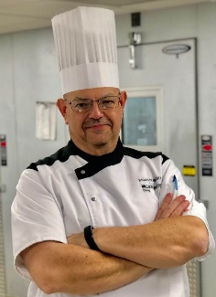

Chef Brian pehr

Executive chef:
Millikin University

March 18, 2019 6pm-8pm

Mari-Mann Herbs 1405 MariMann Ln, Decatur IL 62521

217-429-1555 www.marimann.com

MENU:

Creamy Broccoli Cheddar Chowder Soup with Bacon
Gooder Garlic Bread Seasoned Toast Points w/ Parmesan Cheese
Baby Carrot Salad with Cranberries, Pears, Spinach & Rose Geranium Jelly Drizzle
Hearty Beef and Root Vegetable Stew with Hearty Tomato Broth
Steamed Jasmine Rice
Gooder Seasoned Drop Biscuits with Cheese
Chef’s Special Dessert
$23.00 per Person

Chef Pehr will demonstrate the recipes and provide you with a full ‘Gooder’ meal. You’ll receive the full recipes to take home and try for yourself!
MARI-MANN HERBS
PRESENTS:
March 2019
Soup & Salad Cooking Show
with Executive Chef Brian Pehr

