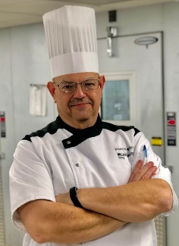
MARI-MANN HERB CO INC / 1405 MARI MANN LANE, DECATUR IL 62521 / 217-429-1555 / www.marimann.com / www.shopmarimann.com

$21.00 per meal, serves 2 people
(Reservations w/pre-payment required)
Chef Pehr will provide you with a full ‘Gooder’ meal with virtual cooking demonstrations. You also receive the full recipes to take home and try for yourself!

Cooking Show demonstrations will be available in a video format for you to watch and follow along to learn Chef Pehr’s cooking method.

Pick up dinners Saturday, January 23rd between 12-4PM

Meals will be packed in portions for 2 people, ready to reheat and eat in the comfort and safety of your own home. Reheating instructions will be provided along with the recipes.

- Brandied Peach BBQ Ribs (full slab)
- Gooder Mac & Cheese
- Extra Brandied Peach BBQ Sauce
January 23, 2021
*DEADLINE TO SIGN UP WED. 1/20/21
MARI-MANN HERBS
PRESENTS:

Gooder BBQ Ribs
Virtual Cooking Show

In Partnership w/ Executive Chef
Brian Pehr

Chef Brian pehr

Executive chef:
Millikin University

